**TUGAS PRAKTIKUM**

**PRAKTIKUM PAW**

**MODUL 4 “PHP Lanjutan”**



|  |
| --- |
| **Disusun Oleh:**  Nama: Fikri Ainun Najib  NIM:200411100153  Kelas: PAW B  **Dosen Pengampu:**  Nama: Ach. Khozaimi, S.Kom., M.Kom  NIP: 19860926 201404 1 001  **Asisten Praktikum:**  Nama: Alief Fadhilah Athallariq  NIM: 180411100028 |

**PRODI TEKNIK INFORMATIKA**

**JURUSAN TEKNIK INFORMATIKA  
FAKULTAS TEKNIK**

**UNIVERSITAS TRUNOJOYO MADURA**

**2022**

1. **Soal:** Buatlah sebuah halaman login berisi username dan password field, tombol login, dan checkbox remember me. Lakukan implementasi session dimana saat user berhasil login dengan remember me dicentang maka akan tersimpan ke dalam session. Jika tidak dicentang maka tidak login tidak tersimpan ke dalam session.

**Source Code:**

|  |
| --- |
| <?php  session_start();  if(isset($_SESSION['login'])){  header("Location: modul4-2.php");  }  if(isset($_POST['submit'])){  if(isset($_POST['check'])){  $_SESSION['login'] = true;  header("Location: modul4-2.php");  }else{  echo '<script language="javascript">';  echo 'alert("Gagal Login")';  echo '</script>';  }  }  ?>  <!doctype html>  <html lang="en">  <head>  <!-- Required meta tags -->  <meta charset="utf-8">  <meta name="viewport" content="width=device-width, initial-scale=1">  <!-- Bootstrap CSS -->  <link href="https://cdn.jsdelivr.net/npm/bootstrap@5.1.3/dist/css/bootstrap.min.css" rel="stylesheet" integrity="sha384-1BmE4kWBq78iYhFldvKuhfTAU6auU8tT94WrHftjDbrCEXSU1oBoqyl2QvZ6jIW3" crossorigin="anonymous">  <title>Inputan Form</title>  </head>  <body>  <h1 class="text-center">Inputan Form</h1>  <div class="container ">  <div class="col-6 position-absolute top-50 start-50 translate-middle">  <form action="#" method="POST">  <label for="username">Username</label><br>  <div class="input-group mb-3">  <input type="text" name="username" class="form-control" placeholder="Enter Username" >  </div>  <label for="password">Password</label><br>  <div class="input-group mb-3">  <input type="password" name="password" class="form-control" placeholder="Enter Password">  </div>  <div class="form-check">  <input class="form-check-input" type="checkbox" name="check" value="checkbok" id="flexCheckChecked">  <label class="form-check-label" for="flexCheckChecked">  Remenber me  </label>  </div>  <input type="submit" name="submit" class="btn btn-primary">  </form>  </div>  </div>  <!-- Option 1: Bootstrap Bundle with Popper -->  <script src="https://cdn.jsdelivr.net/npm/bootstrap@5.1.3/dist/js/bootstrap.bundle.min.js" integrity="sha384-ka7Sk0Gln4gmtz2MlQnikT1wXgYsOg+OMhuP+IlRH9sENBO0LRn5q+8nbTov4+1p" crossorigin="anonymous"></script>  </body>  </html> |

**Screenshoot:**

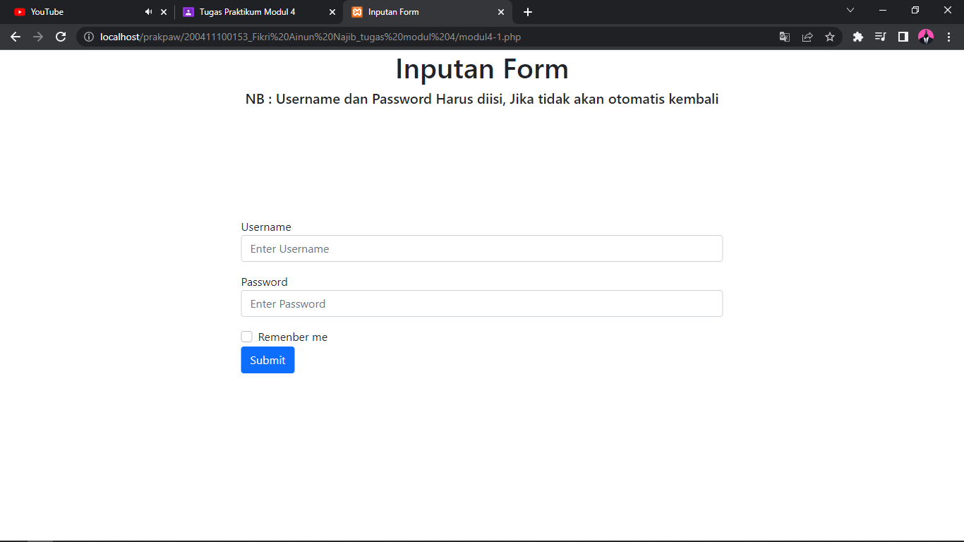

1. **Soal:** Setelah login, user akan dihadapkan pada halaman daftar mahasiswa seperti contoh dibawah ini. Pembuatan tabel dilakukan dengan memanfaatkan PHP dan isi pada table disimpan pada multidimensional array. Jika user menekan tombol logout maka session akan berakhir dan kembali ke halaman login.

**Source Code:**

|  |
| --- |
| <?php  session_start();  if(!isset($_SESSION['login'])){  header("Location: modul4-1.php");  }  $data = array (  array("Fikri",200411100153,"Jl cendrawasih no.1"),  array("ainun",200411100154,"Jl cendrawasih no.2"),  array("najib",200411100155,"Jl cendrawasih no.4"),  array("slamet",200411100156,"Jl cendrawasih no.3")  );  if(isset($_POST['logout'])){  session_destroy();  header("Location: modul4-1.php");  }  ?>  <!doctype html>  <html lang="en">  <head>  <!-- Required meta tags -->  <meta charset="utf-8">  <meta name="viewport" content="width=device-width, initial-scale=1">  <!-- Bootstrap CSS -->  <link href="https://cdn.jsdelivr.net/npm/bootstrap@5.1.3/dist/css/bootstrap.min.css" rel="stylesheet" integrity="sha384-1BmE4kWBq78iYhFldvKuhfTAU6auU8tT94WrHftjDbrCEXSU1oBoqyl2QvZ6jIW3" crossorigin="anonymous">  <title>Inputan Form</title>  </head>  <body>  <h1 class="text-center">Inputan Form</h1>    <div class="container ">  <div class="col-6 position-absolute top-50 start-50 translate-middle">  <table class="table">  <thead>  <tr>    <th scope="col">Nama Mahasiswa</th>  <th scope="col">NIM</th>  <th scope="col">Alamat</th>  </tr>  </thead>  <tbody>  <?php  for ($row = 0; $row < count($data)-1; $row++) {  echo "<tr> <td>".$data[$row][0] ."</td><td>".$data[$row][1] ."</td><td>".$data[$row][2] ."</td></tr>";  }  ?>  </tbody>  </table>  <form action="#" method="POST">  <input type="submit" name="logout" value="logout">  </form>  </div>  </div>  <!-- Option 1: Bootstrap Bundle with Popper -->  <script src="https://cdn.jsdelivr.net/npm/bootstrap@5.1.3/dist/js/bootstrap.bundle.min.js" integrity="sha384-ka7Sk0Gln4gmtz2MlQnikT1wXgYsOg+OMhuP+IlRH9sENBO0LRn5q+8nbTov4+1p" crossorigin="anonymous"></script>  </body>  </html> |

**Screenshoot:**

